**Jquery basic, Effects & advanced**

# 1.what is Jquery

ans. jQuery is a fast, small, and feature-rich JavaScript library. It makes things like HTML document traversal and manipulation, event handling, animation, and Ajax much simpler with an easy-to-use API that works across a multitude of browsers. With a combination of versatility and extensibility, jQuery has changed the way that millions of people write JavaScript.

**2.How to Apply CSS Using JQuery, How to Add Class**

**and Remove Class in JQuery, JQuery Animation?**

ans. apply css using JQuery: the css() method sets or return one or more style properties for the selected elements.

to return the value of a specified css propery. exa. css("propertyname");

$("p").css("background-color","yellow");

how to add class and remove class in jQuery

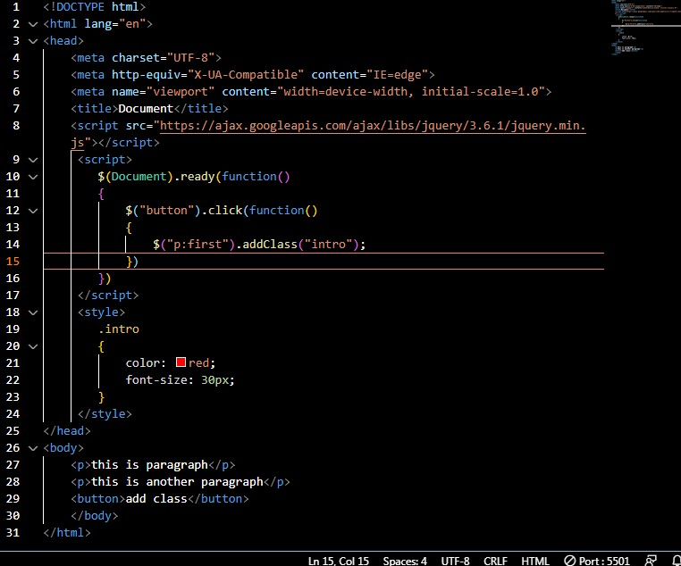

by the same method you can remove class in Jquery.

Jquery animation hide element example:

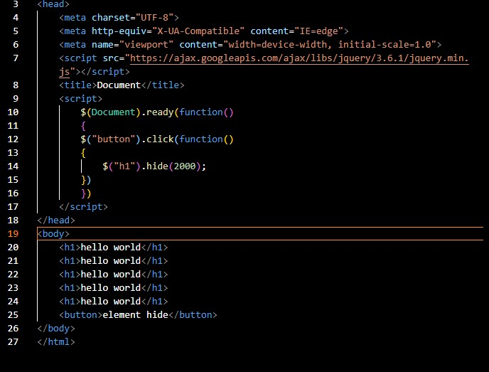

hide and show

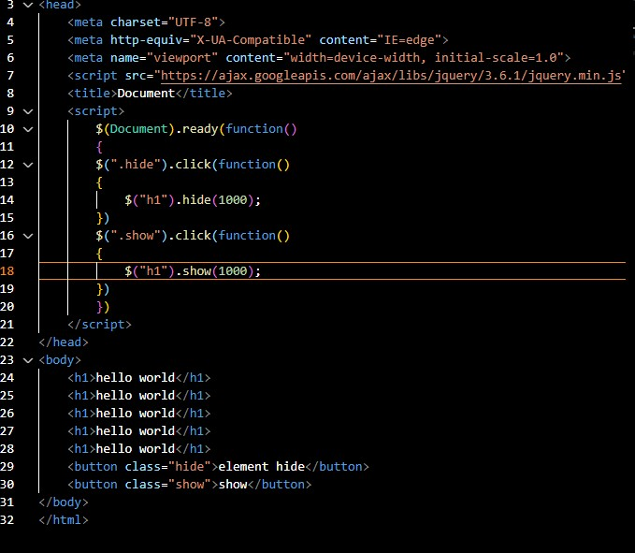

fade in and fade out

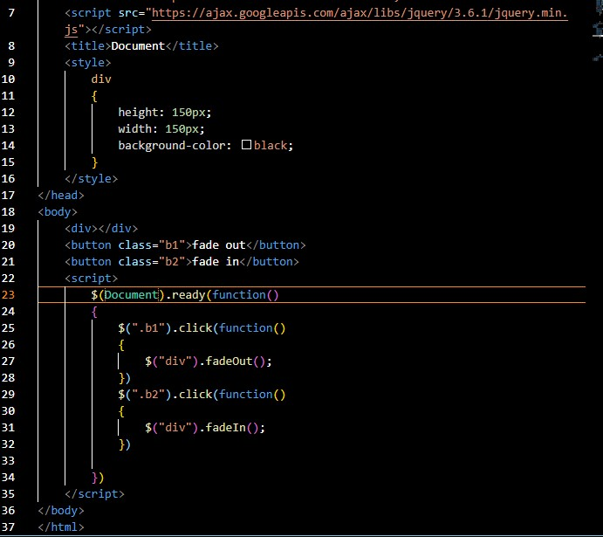

toggle

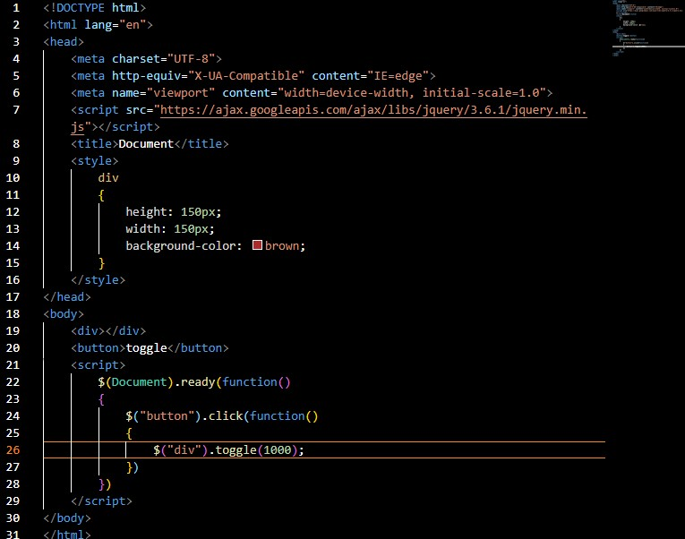

**2. how to create slider with animation?**

ans. you can make slider using three types

1.slidedown()

2.slideup()

3.slidetoggle()

slidedown() and slideup()

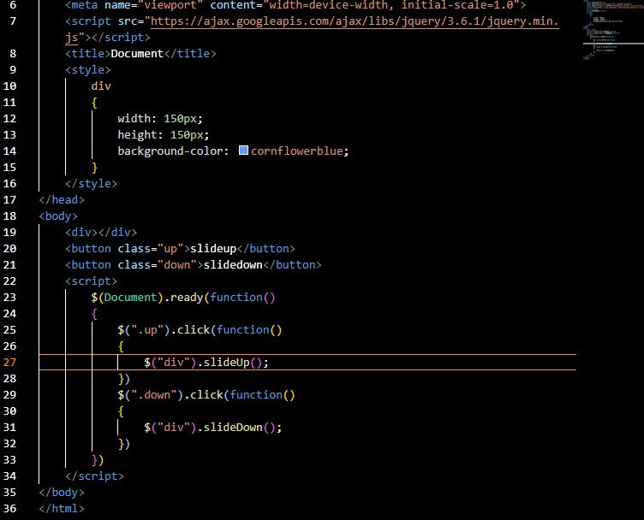

slidetoggle()

